A CRM APPLICATION FOR THE CHAISHOP&CO
PROJECT DOCUMENTATION
Salesforce - Based Customer Relationship Management System

USER STORY
As a sales representative at TheChaiShop&Co, I want to efficiently manage customer relationships and streamline sales processes using our CRM application. I want to easily access and update customer and employer details, as well as distinguish between online and offline customer records using record types, allowing for personalized interactions. Additionally, I need the application to automate sales calculations, such as order quantity and total bill amount, to ensure accurate and efficient transactions. Moreover, I require the ability to generate insightful reports and dashboards to summarize and analyze sales data effectively, aiding in decision-making and strategy development. Lastly, I would like the application to automate email notifications to customers on their birthdays, informing them of special offers tailored to celebrate their special day, enhancing customer engagement and loyalty.

1. INTRODUCTION

1.1 Project Overview
The project “A CRM Application for The Chai Shop & Co” focuses on developing a Salesforce-based Customer Relationship Management (CRM) system to manage customer, employer, and enterprise accounts efficiently. The application brings customer information, sales activities, order details, and communication into a centralized platform. It is intended to reduce manual work and provide a structured approach to handling customer relationships.
The system supports customer record management, online and offline customer classification, sales calculation, reporting, dashboards, and automated customer communication. By combining these capabilities in one CRM environment, The Chai Shop & Co can maintain more consistent data and provide timely information to its sales and management teams.
The project user story and objectives are defined in the initial section of the document. The following ideation phase identifies the major user problems, user expectations, and possible solutions that lead to the selected Salesforce-based CRM application.

1.2 Purpose
The purpose of this project is to:
- Streamline customer relationship management.
- Automate billing and order calculations.
- Improve data accuracy and reduce manual entry errors.
- Enable data-driven decision-making through reports and dashboards.
- Enhance customer engagement through automated email notifications.
- Maintain organized customer records for online and offline interactions.

2. IDEATION PHASE

2.1 Problem Statement (Customer Problem Statement Template)
The problem statement identifies the main difficulties faced by the people who use the CRM process. It is structured around the user, the task they are trying to complete, the obstacle, the reason for the obstacle, and the resulting feeling.
PS | I am (Customer) | I'm trying to | But | Because | Which makes me feel
PS-1 | Sales Representative | Manage customer orders and billing | Calculations are often incorrect | Order quantity and billing are manual | Stressed and inefficient
PS-2 | Store Manager | Monitor sales and customer records | Reports are delayed and incomplete | Data is stored in multiple files | Confused and dissatisfied
PS-3 | Customer | Receive personalized offers and notifications | I do not get timely notifications | There is no automated communication | Disconnected and undervalued

Problem Summary
The identified problems are mainly related to manual sales calculations, fragmented customer data, delayed reporting, and the absence of automated customer communication. These issues can affect operational efficiency as well as the consistency of customer service. The proposed CRM therefore needs to centralize data and automate repetitive activities.

2.2 Empathy Map Canvas

Target Users
- Sales Representatives
- Managers
- System Administrators
- Business Analysts

Empathy Analysis
Aspect | Description
Think & Feel | Need accurate customer data and reliable reports.
Hear | Feedback and requirements from management and customers.
See | Multiple registers, spreadsheets, and separate customer records.
Say & Do | Enter customer, order, and sales data manually.
Pain | Errors, delays, duplicate records, and possible data loss.
Gain | Automation, faster reports, accurate calculations, and better customer service.
The empathy map shows that users need a centralized system that reduces repetitive data entry and gives them quick access to trustworthy information. Sales staff need faster order handling, managers need clear reports, administrators need controlled data management, and customers need timely and relevant communication.

2.3 Brainstorming

Brainstormed Ideas
- Manual CRM system
- Excel-based management
- Web-based CRM
- Salesforce-based CRM
- Automated email system

Evaluation of Ideas
Idea | Main Benefit | Main Limitation
Manual CRM system | Simple to start | High manual effort and error risk
Excel-based management | Easy for basic data storage | Limited automation and collaboration
Web-based CRM | Centralized access | Requires broader application development
Salesforce-based CRM | Automation, reports, dashboards and centralized records | Requires Salesforce configuration and training
Automated email system | Improves customer communication | Does not manage the complete sales process alone

Selected Idea
Salesforce - based CRM Application for The Chai Shop & Co.
The selected idea combines customer and sales management with automation, reporting, and communication. Salesforce is used as the platform for organizing customer information, supporting business processes, and presenting useful sales insights. The solution is designed to address the problems identified during the problem-statement and empathy-map activities.

Expected Outcome
- Centralized customer and account information.
- Clear separation of online and offline customer records.
- Automated order quantity and total bill calculations.
- Reports and dashboards for sales analysis.
- Automated birthday email notifications and special-offer communication.
- Reduced manual effort and improved data consistency.

Implementation

Milestone 1 - Salesforce developer account creation:

Activity 1: Creating Developer Account:
Creating a developer org in salesforce.
- Go to https://developer.salesforce.com/signup
- On the sign-up form, enter the following details:
https://developers.salesforce.com/Signup*
- First name & Last name
- Email
- Role: Developer
- Company: College or Company Name
- Country: India
- Postal Code: pin code
- Username: should be a combination of your name and company
This need not be an actual email id; you can give anything in that format:username@organization.com

Activity 2: Account Activation:
- Go to the inbox of the email that you used while signing up. Click on the verify account to activate your account. The email may take 5-10mins.
- Click on Verify Account.
- Give a password and answer a security question and click on change password.
- Then you will redirect to your salesforce setup page.

Milestone 2 - Objects
- In your Salesforce org, click the gear icon on the top left and select Setup to open Setup.
- Click the Object Manager tab. If you don’t see it, enter Object Manager in the Quick Find box.
- On the Object Manager page, click Create | Custom Object.

Activity 1: Employer Account Object
- From the setup page → Click on Object Manager → Click on Create → Click on Custom Object.
- Label: Employer Account
- Plural Label: Employer Accounts
- Enter Record Name Label and Format
Record Name: Employer Account Name
Data Type: Text
- In Optional features: check the boxes for Allow Reports | Allow Activities | Track Field History.
- Search Status:Check the box for Allow Search.
- Save

Activity 2: Customer Account Object
- From the setup page → Click on Object Manager → Click on Create → Click on Custom Object.
- Label: Customer Account
- Plural Label: Customer Accounts
- Enter Record Name Label and Format
Record Name: Customer Account Name
Data Type: Text
- In Optional features: check the boxes for Allow Reports | Allow Activities | Track Field History.
- Search Status:Check the box for Allow Search.
- Save

Activity 3: Enterprise Account Object
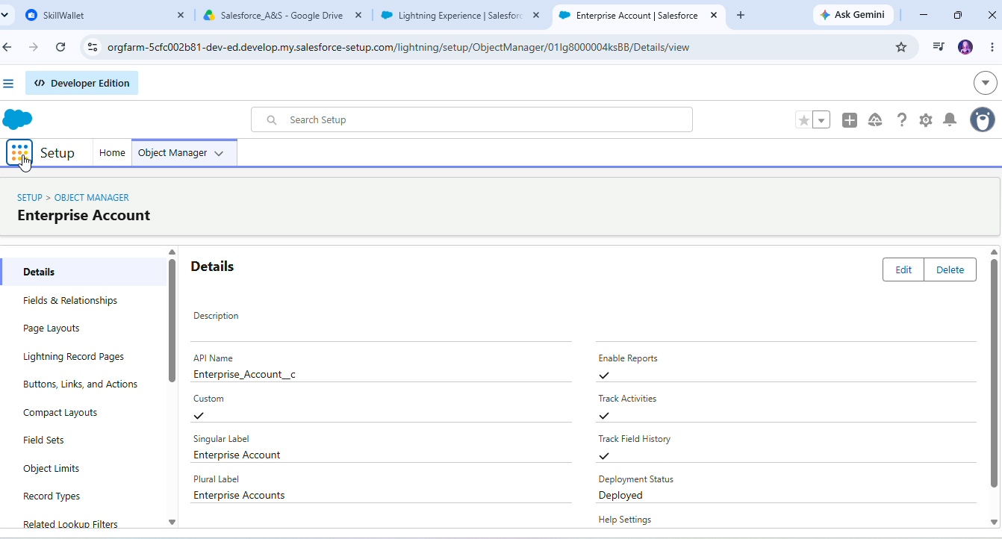
- From the setup page → Click on Object Manager → Click on Create → Click on Custom Object.
- Label: Enterprise Account
- Plural Label: Enterprise Accounts
- Enter Record Name Label and Format
Record Name: Enterprise Account Name
Data Type: Text
- In Optional features: check the boxes for Allow Reports | Allow Activities | Track Field History.
- Search Status:Check the box for Allow Search.
- Save

Milestone 3 -Tabs

Activity 1: Custom tabs creation
- Go to setup page → type Tabs in Quick Find bar → click on tabs → New (under custom object tab)
- Select Object (Employer Accounts) → Select the tab style → Next (Add to profiles page) keep it as default → Next (Add to Custom App) uncheck the includedtab.
- Make sure that the Append tab to users' existing personal customizations is checked.
- Click Save.
- Repeat the same steps for Customer Accounts and Enterprise Accounts.

Milestone 4 - The Lightning App
Activity 1: Create a lightning app
- Go to setup page → search “app manager” in quick find → select “app manager” → click on new lightning App.
- Fill the app name in app details and branding as follow
- App Name: TheChaiShop&Co
- Developer Name: Auto Populates
- Add image optional (if you want to give any image you can otherwise not mandatory) - Add Primary color Hex or leave it to default.
Then click Next.
- In App options
Navigation style: Standard navigation
Setup experience: setup
Supporters form factors: Desktop and phone
Then click Next.
- In Utility items
Utility Bar alignment: Default
Then click Next.
- Navigation items
Select the created Custom Objects and required standard objects
- Customer Accounts
Employer Accounts
Enterprise Accounts
Reports
Dashboards
- To Add User Profiles: System Administrator
- Click Save & Finish.

Milestone 5: Global Picklist
Activity 1: Create Global Picklist
- In Quick Find Box Searchfor: Picklist value sets and click New.

- Label: Gender
Name: Auto Populates
Values: Male
Female
Others
Click Save & New.
- Create three more Global picklists following the same steps.
- Label: Items
Name: Auto populates
Values: Platinum Tea Powder
Double Delight Tea Powder
Super Dust Tea Powder
Osmania Biscuits (Value Pack)
Osmania Biscuits (Premium Pack)
Dry Fruit Biscuits
Fruit Biscuits
Salt Biscuits
Multigrain Biscuits
Ragi Biscuits
Double Choco Chip Cookies
Butter Almond Cookies
Melting Moments Cookies
Honey Oats Cookies
Delight Box
Signature Box
Assorted Box
Click Save & New.
- Label: Payment Mode
Name: Auto populates
Values: Gpay
PhonePe
Paytm
Credit or Debit card
Cash.
Click Save & New.
- Label: Type of Items
Name: Auto populates
Values: Tea powder
Cookies
Gift Hampers
Click Save.

Milestone 6: Fields & Relationships

Activity 1: Create Custom fields for Employer Account
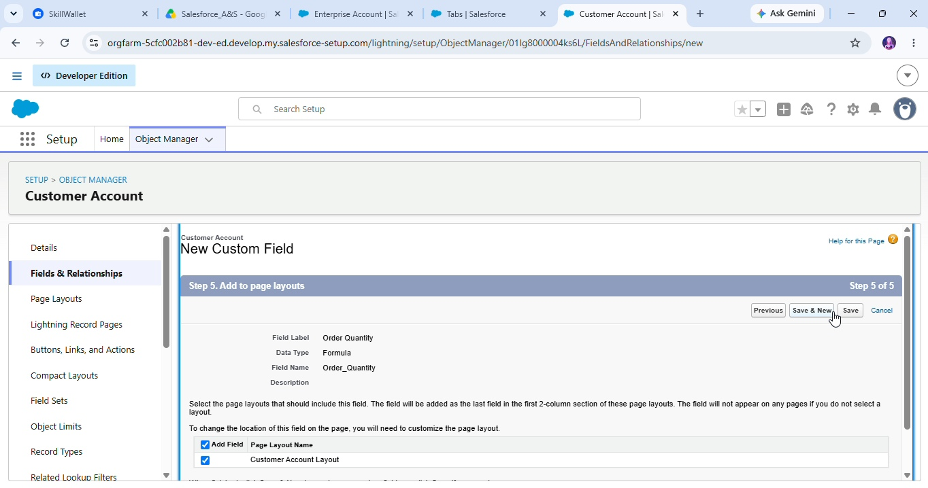
In your Salesforce org, click the gear icon on the top left and select Setup to open Setup.
Click the Object Manager tab. If you don’t see it, enter Object Manager in the Quick Find box.
From the object manager page, In the Quick Find box, Search for the custom object you just created: Employer Account
From the sidebar, click Fields & Relationships. Notice that there are already some fields there. Those are the standard fields.
Click New to create a custom field. Tip: Before creating a new field, do a quick search to make sure a similar one doesn’t already exist.
Next, choose a data type as Text. Choosing a data type helps you format the field input.
Click on next
- Data Type: Text
Field Label: First Name
Field Name: Auto Populates
Length: 25
Required: Check the box
Click Next → Next → Save and New.

Repeat the Same steps for remaining fields

- Data Type: Text
Field Label: Last Name
Field Name: Auto Populates
Length: 25
Required: Check the box
Click Next → Next → Save and New.

- Data Type:Picklist
Field Label: Gender
Values: Use Global Picklist value set and
Select Gender from the dropdown menu.
Field Name: Auto Populates.
Required: Check the box
Click Next → Next → Save and New.

- Data Type: Phone
Field Label: Phone Number
Field Name: Auto Populates
Required: Check the box
Click Next → Next → Save and New.

- Data Type: Email
Field Label: Email ID
Field Name: Auto Populates
Required: Check the box
Click Next → Next → Save and New.

- Data Type: Date
Field Label: Date of Birth
Field Name: Auto Populates
Required: check the box
Click Next → Next → Save and New.

- Data Type: Text
Field Label: Aadhar Number
Field Name: Auto Populates
Length: 12
Click Next → Next → Save and New.

- Data Type: Text
Field Label: PAN Details
Field Name:PAN Details
Length: 10
Click Next → Next → Save and New.

- Data Type: Picklist
Field Label: Designation
Field Name: Auto Populates
Value: Enter value, with each value separated by a new line.
Manager
Finance and Accounting
Kitchen Staff
Cashier
Servers
Click Next → Next → Save and New.

- Data Type: Currency
Field Label: Salary
Field Name: Auto Populates
Click Next → Next → Save.

Activity 2: Create Custom fields for Customer Account

- Data Type: Text
Field Label: First Name
Field Name: Auto Populates
Length: 25
Required: Check the box
Click Next → Next → Save and New.

- Data Type: Text
Field Label: Last Name
Field Name: Auto Populates
Length: 25
Required: Check the box
Click Next → Next → Save and New.

- Data Type:PickList
Field Label: Gender
Values: Use Global Picklist value set and
Select Gender from the dropdown menu.
Field Name: Auto Populates.
Required: Check the box
Click Next → Next → Save and New.

- Data Type: Phone
Field Label: Phone Number
Field Name: Auto Populates
Required: Check the box
Click Next → Next → Save and New.

- Data Type: Date
Field Label: Date of Birth
Field Name: Auto Populates
Required: check the box
Click Next → Next → Save and New.

- Data Type:Formula
Field Label: Date of Birthday is today?
Field Name: Auto Populates
Formula Return: Checkbox
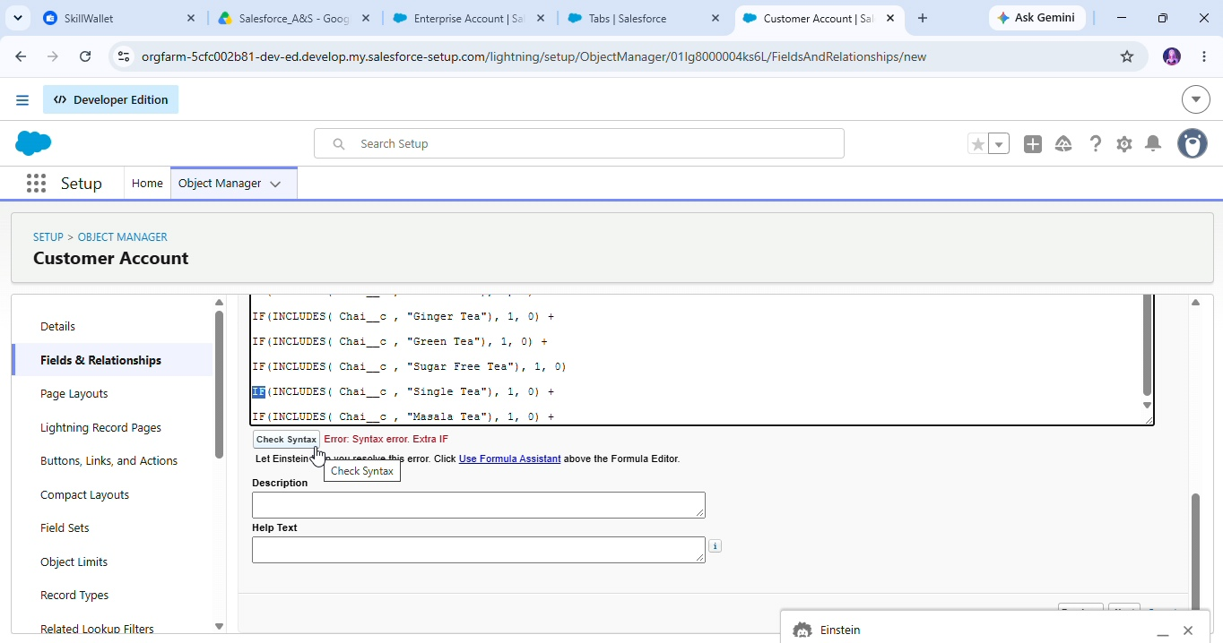
Formula:
IF (
AND (
DAY (TODAY ()) = DAY( Date_of_Birth__c ) ,
MONTH (TODAY ()) = MONTH( Date_of_Birth__c )),
TRUE,
FALSE)
Click Next → Next → Save and New.

- Data Type: Email
Field Label: Email ID
Field Name: Auto Populates
Required: Check the box
Click Next → Next → Save and New.

- Date Type: Text
Field Label: Address
Field Name: Auto Populates
Length: 125
Click Next → Next → Save and New.

- Date Type: Multi Select Picklist
Field Label: Type of Items
Values: Use Global Picklist value set and
Select Type of Items from the dropdown menu.
Field Name: Auto Populates.
Required: Check the box
Click Next → Next → Save and New.

- Date Type: Multi Select Picklist
Field Label: Products purchased
Values: Use Global Picklist value set and
select Items from the dropdown menu.
Field Name: Auto Populates.
Required: Check the box
Click Next → Next → Save and New.

- Date Type: Multi Select Picklist
Field Label: Chai
Value: Enter value, with each value separated by a new line.
TheChaiShop&Co Special Tea
Single Tea
Masala Tea
Lemon Tea
Ginger Tea
Green Tea
Sugar Free Tea
Click Next → Next → Save and New.

- Data Type: Picklist
Field Label: Payment Mode
Values: Use Global Picklist value set and
Select Payment Mode from the dropdown menu.
Field Name: Auto Populates.
Required: Check the box
Click Next → Next → Save and New.

- Data Type: Lookup Relationship
Related To: Employer Account
Field Label: Associated Employer
Field Name: Auto Populates
Click Next → Next → Save and New.

- Data Type: Formula
Field Label: Order Quantity
Field Name: Auto Populates
Formula Return: Number

Enter Formula = Quantity (Number) =
IF (INCLUDES( Products_Purchased__c , "Platinum Tea Powder"), 1, 0) +
IF (INCLUDES( Products_Purchased__c , "Double Delight Tea Powder"), 1, 0) +
IF (INCLUDES( Products_Purchased__c , "Super Dust Tea Powder"), 1, 0) +
IF (INCLUDES( Products_Purchased__c , "Osmania Biscuits (Value Pack)"), 1, 0) +
IF (INCLUDES( Products_Purchased__c , "Osmania Biscuits (Premium Pack)"), 1, 0) +
IF (INCLUDES( Products_Purchased__c , "Dry Fruit Biscuits"), 1, 0) +
IF (INCLUDES( Products_Purchased__c , "Fruit Biscuits"), 1, 0) +
IF (INCLUDES( Products_Purchased__c , "Salt Biscuits"), 1, 0) +
IF (INCLUDES( Products_Purchased__c , "Multigrain Biscuits"), 1, 0) +
IF (INCLUDES( Products_Purchased__c , "Ragi Biscuits"), 1, 0) +
IF (INCLUDES( Products_Purchased__c ,"Double Choco chip Cookies"), 1, 0) +
IF (INCLUDES( Products_Purchased__c , "Butter Almond Cookies"), 1, 0) +
IF (INCLUDES( Products_Purchased__c , "Melting Moments Cookies"), 1, 0) +
IF (INCLUDES( Products_Purchased__c , "Honey Oats Cookies"), 1, 0) +
IF (INCLUDES( Products_Purchased__c , "Delight Box"), 1, 0) +
IF (INCLUDES( Products_Purchased__c , "Signature Box"), 1, 0) +
IF (INCLUDES( Products_Purchased__c , "Assorted Pack"), 1, 0) +
IF (INCLUDES( Chai__c , "TheChaiShop&Co Special Tea"), 1, 0) +
IF (INCLUDES( Chai__c , "Single Tea"), 1, 0) +
IF (INCLUDES( Chai__c , "Masala Tea"), 1, 0) +
IF (INCLUDES( Chai__c , "Lemon Tea"), 1, 0) +
IF (INCLUDES( Chai__c , "Ginger Tea"), 1, 0) +
IF (INCLUDES( Chai__c , "Green Tea"), 1, 0) +
IF (INCLUDES( Chai__c , "Sugar Free Tea"), 1, 0)
Click Next → Next → Save and New.

- Data Type: Formula
Field Label: Total Bill
Field Name: Auto Populates
Formula Return: Number
Enter Formula = Quantity (Number) =
IF (INCLUDES( Products_Purchased__c , "Platinum Tea Powder"), 175, 0) +
IF (INCLUDES( Products_Purchased__c , "Double Delight Tea Powder"), 150, 0) +
IF (INCLUDES( Products_Purchased__c , "Super Dust Tea Powder"), 125, 0) +
IF (INCLUDES( Products_Purchased__c , "Osmania Biscuits (Value Pack)"), 50, 0) +
IF (INCLUDES( Products_Purchased__c , "Osmania Biscuits (Premium Pack)"), 80, 0) +
IF (INCLUDES( Products_Purchased__c , "Dry Fruit Biscuits"), 110, 0) +
IF (INCLUDES( Products_Purchased__c , "Fruit Biscuits"), 160, 0) +
IF (INCLUDES( Products_Purchased__c , "Salt Biscuits"), 110, 0) +
IF (INCLUDES( Products_Purchased__c , "Multigrain Biscuits"), 170, 0) +
IF (INCLUDES( Products_Purchased__c , "Ragi Biscuits"), 190, 0) +
IF (INCLUDES( Products_Purchased__c ,"Double Choco chip Cookies"), 200, 0) +
IF (INCLUDES( Products_Purchased__c , "Butter Almond Cookies"), 110, 0) +
IF (INCLUDES( Products_Purchased__c , "Melting Moments Cookies"), 150, 0) +
IF (INCLUDES( Products_Purchased__c , "Honey Oats Cookies"), 160, 0) +
IF (INCLUDES( Products_Purchased__c , "Delight Box"), 850, 0) +
IF (INCLUDES( Products_Purchased__c , "Signature Box"), 1500, 0) +
IF (INCLUDES( Products_Purchased__c , "Assorted Pack"), 600, 0) +
IF (INCLUDES( Chai__c , "TheChaiShop&Co Special Tea"), 70, 0) +
IF (INCLUDES( Chai__c , "Single Tea"), 50, 0) +
IF (INCLUDES( Chai__c , "Masala Tea"), 60, 0) +
IF (INCLUDES( Chai__c , "Lemon Tea"), 40, 0) +
IF (INCLUDES( Chai__c , "Ginger Tea"),55, 0) +
IF (INCLUDES( Chai__c , "Green Tea"), 45, 0) +
IF (INCLUDES( Chai__c , "Sugar Free Tea"), 55, 0)
Click Next → Next → Save.

Activity 3: Create Custom fields for Enterprise Account

- Data Type: Text
Field Label: Enterprise Name
Field Name: Auto Populates
Length: 25
Required: Check the box
Click Next → Next → Save and New.

- Data Type: Phone
Field Label: Phone Number
Field Name: Auto Populates
Required: Check the box
Click Next → Next → Save and New.

- Data Type: Email
Field Label: Email ID
Field Name: Auto Populates
Required: Check the box
Click Next → Next → Save and New.

- Date Type: Text
Field Label: Address
Field Name: Auto Populates
Length: 125
Click Next → Next → Save and New.

- Date Type: Multi Select Picklist
Field Label: Type of Items
Values: Use Global Picklist value set and
Select Type of Items from the dropdown menu.
Field Name: Auto Populates.
Required: Check the box
Click Next → Next → Save and New.

- Date Type: Multi Select Picklist
Field Label: Products purchased
Values: Use Global Picklist value set and
select Items from the dropdown menu.
Field Name: Auto Populates.
Required: Check the box
Click Next → Next → Save and New.

- Data Type: Lookup Relationship
Related To: Employer Account
Field Label: Associated Employer
Field Name: Auto Populates
Click Next → Next → Save and New.

- Data Type: Formula
Field Label: Order Quantity
Field Name: Auto Populates
Formula Return: Number
Enter Formula = Quantity (Number) =
IF (INCLUDES( Products_Purchased__c , "Platinum Tea Powder"), 1, 0) +
IF (INCLUDES( Products_Purchased__c , "Double Delight Tea Powder"), 1, 0) +
IF (INCLUDES( Products_Purchased__c , "Super Dust Tea Powder"), 1, 0) +
IF (INCLUDES( Products_Purchased__c , "Osmania Biscuits (Value Pack)"), 1, 0) +
IF (INCLUDES( Products_Purchased__c , "Osmania Biscuits (Premium Pack)"), 1, 0) +
IF (INCLUDES( Products_Purchased__c , "Dry Fruit Biscuits"), 1, 0) +
IF (INCLUDES( Products_Purchased__c , "Fruit Biscuits"), 1, 0) +
IF (INCLUDES( Products_Purchased__c , "Salt Biscuits"), 1, 0) +
IF (INCLUDES( Products_Purchased__c , "Multigrain Biscuits"), 1, 0) +
IF (INCLUDES( Products_Purchased__c , "Ragi Biscuits"), 1, 0) +
IF (INCLUDES( Products_Purchased__c ,"Double Choco chip Cookies"), 1, 0) +
IF (INCLUDES( Products_Purchased__c , "Butter Almond Cookies"), 1, 0) +
IF (INCLUDES( Products_Purchased__c , "Melting Moments Cookies"), 1, 0) +
IF (INCLUDES( Products_Purchased__c , "Honey Oats Cookies"), 1, 0) +
IF (INCLUDES( Products_Purchased__c , "Delight Box"), 1, 0) +
IF (INCLUDES( Products_Purchased__c , "Signature Box"), 1, 0) +
IF (INCLUDES( Products_Purchased__c , "Assorted Pack"), 1, 0)
Click Next → Next → Save and New.

- Data Type: Formula
Field Label: Total Bill
Field Name: Auto Populates
Formula Return: Number
Enter Formula = Quantity (Number) =
IF (INCLUDES( Products_Purchased__c , "Platinum Tea Powder"), 175, 0) +
IF (INCLUDES( Products_Purchased__c , "Double Delight Tea Powder"), 150, 0) +
IF (INCLUDES( Products_Purchased__c , "Super Dust Tea Powder"), 125, 0) +
IF (INCLUDES( Products_Purchased__c , "Osmania Biscuits (Value Pack)"), 50, 0) +
IF (INCLUDES( Products_Purchased__c , "Osmania Biscuits (Premium Pack)"), 80, 0) +
IF (INCLUDES( Products_Purchased__c , "Dry Fruit Biscuits"), 110, 0) +
IF (INCLUDES( Products_Purchased__c , "Fruit Biscuits"), 160, 0) +
IF (INCLUDES( Products_Purchased__c , "Salt Biscuits"), 110, 0) +
IF (INCLUDES( Products_Purchased__c , "Multigrain Biscuits"), 170, 0) +
IF (INCLUDES( Products_Purchased__c , "Ragi Biscuits"), 190, 0) +
IF (INCLUDES( Products_Purchased__c ,"Double Choco chip Cookies"), 200, 0) +
IF (INCLUDES( Products_Purchased__c , "Butter Almond Cookies"), 110, 0) +
IF (INCLUDES( Products_Purchased__c , "Melting Moments Cookies"), 150, 0) +
IF (INCLUDES( Products_Purchased__c , "Honey Oats Cookies"), 160, 0) +
IF (INCLUDES( Products_Purchased__c , "Delight Box"), 850, 0) +
IF (INCLUDES( Products_Purchased__c , "Signature Box"), 1500, 0) +
IF (INCLUDES( Products_Purchased__c , "Assorted Pack"), 600, 0)

- Data Type: Picklist
Field Label: Payment Mode
Values: Use Global Picklist value set and
Select Payment Mode from the dropdown menu.
Field Name: Auto Populates.
Required: Check the box
Click Next → Next → Save.

7. FUNCTIONAL & PERFORMANCE TESTING
The testing phase was conducted to verify that the Salesforce CRM application functions according to the defined requirements. Each major feature was tested using appropriate test scenarios, and screenshots were captured from the Salesforce Lightning interface as evidence of successful implementation.

7.1 Functional Testing
The following functional areas were tested:
- Object Record Creation:Verified in the creation and storage of records for Customer, Employer, Enterprise, and other configured objects.
- Data Validation: Tested validation rules for applicable fields such as Aadhaar, PAN, and phone numbers to ensure that invalid data is rejected.
- Record Types and Page Layouts: Verified that the appropriate record type and page layout are displayed according to the configured business requirements.
- Fields and Relationships: Verified that required fields and relationships between objects function correctly.
- Formula Fields: Tested formula calculations related to order quantity, price, and billing amounts.
- Flow Automation: Verified that configured Salesforce Flows execute correctly when their specified conditions are met.
- Email Automation: Tested birthday offers and other configured email notifications to verify that the appropriate email action is triggered.
- Reports: Verified that reports display the expected customer, order, sales, and business information.
- Dashboards: Verified that dashboard components correctly represent the underlying report data.
- User Access: Tested Profiles and Permission Sets to verify that users can access only the required features and information.

Functional Testing Summary
Test Area | Expected Result | Status
Customer Record Creation | Customer record should be created successfully with valid data | Passed
Employer/Enterprise Records | Records should be stored correctly | Passed
Phone Validation | Invalid phone number should be rejected | Passed
PAN Validation | Invalid PAN format should be rejected | Passed
Aadhaar Validation | Invalid Aadhaar input should be rejected | Passed
Record Types | Appropriate record type should be available | Passed
Page Layouts | Required fields should be displayed correctly | Passed
Billing Formula | Billing amount should be calculated according to configured formula | Passed
Flow Automation | Flow should execute when its conditions are satisfied | Passed
Email Notification | Configured email action should be triggered correctly | Passed
Reports | Required CRM information should be displayed | Passed
Dashboards | Report data should be represented correctly | Passed

7.2 Performance Testing
Performance testing was considered to verify that the CRM application provides an acceptable user experience when working with records, reports, dashboards, and automation.
The following areas were observed:
- Salesforce pages and records should be loaded without unnecessary delays.
- Record creation and editing should respond appropriately.
- Reports should process the configured data without significant delay.
- Dashboards should display their components correctly.
- Salesforce Flows should execute without unnecessary processing.
- The application should remain usable as the volume of CRM records increases.
Performance observations can be documented based on actual testing performed during the project.

8. ADVANTAGES & DISADVANTAGES

8.1 Advantages
The Salesforce CRM application provides the following advantages:
- Centralized Data Management – Customer, order, and business information can be maintained in a centralized Salesforce environment.
- Reduced Manual Work – Salesforce Flows and automation reduce repetitive administrative activities.
- Improved Data Accuracy – Validation rules and standardized field values help reduce incorrect data entry.
- Automated Calculations – Formula fields can perform configured order and billing calculations automatically.
- Improved Customer Communication – Automated email notifications can support birthday offers, order-related communication, and other customer interactions.
- Better Business Visibility – Reports and dashboards provide structured views of CRM and business information.
- Controlled Data Access – Profiles, Permission Sets, and sharing controls help manage user access.
- Cloud-Based Accessibility – Authorized users can access the CRM application through the Salesforce platform from supported devices and locations.

8.2 Disadvantages
The system also has some limitations:
- Salesforce Cost – Access to Salesforce features may depend on the organization's selected Salesforce edition, licenses, and configuration.
- Internet Dependency – Most Salesforce CRM activities require network connectivity.
- Limited Offline Functionality – Some CRM operations may not be available when the user is offline.
- Platform Dependency – The application depends on the Salesforce platform and its supported features.
- Configuration Complexity – Advanced customization and automation may require Salesforce administration or development knowledge.
- Data Migration Effort – Moving existing data from spreadsheets or legacy systems into Salesforce may require additional planning and data-cleaning activities.

Important correction
I recommend replacing “Real-time analytics” with “Better Business Visibility” or “Improved Business Analysis.”
Reports and dashboards can provide current information from Salesforce data, but claiming “real-time analytics” may imply a specific real-time architecture that your project may not actually implement.

9. CONCLUSION
The TheChaiShop&Co CRM Application demonstrates how Salesforce can be used to develop a centralized CRM solution for managing customer and business information. The application integrates data management, validation, automation, billing-related calculations, email notifications, reports, and dashboards within a cloud-based Salesforce environment.
The implementation reduces dependency on manual record management and helps improve data consistency through validation rules and standardized values. Salesforce Flows automate selected business processes, while Reports and Dashboards provide useful information for monitoring and analyzing business activities.
The project also provides practical implementation experience with Salesforce objects, fields, relationships, page layouts, record types, validation rules, email templates, Flow automation, security, reports, and dashboards.
Overall, the project demonstrates the application of Salesforce CRM capabilities to create a structured, automated, and scalable business management solution for TheChaiShop&Co.

10. FUTURE SCOPE
The CRM application can be enhanced in the future with additional features to support the growing requirements of the business.

10.1 Mobile CRM Integration
The application can be extended and optimized for mobile users so that sales representatives and managers can access important CRM information while working remotely.

10.2 AI-Based Sales Prediction
AI and Salesforce-supported analytics can be explored to identify sales patterns, forecast potential demand, and provide data-driven insights.

10.3 WhatsApp / SMS Notifications
Integration with appropriate communication services could allow the system to send customer notifications through WhatsApp or SMS in addition to email.

10.4 Inventory Management
An inventory module could be introduced to track product quantities, stock availability, stock movement, and reorder requirements.

10.5 Multi-Branch Support
The application could be extended to support multiple branches or business locations with appropriate data visibility and access controls.

10.6 Advanced Customer Profiling
Customer information could be enhanced with segmentation, purchase history, preferences, interaction history, and other relevant attributes to support personalized customer engagement.

10.7 Advanced Analytics
Additional reports, dashboards, forecasting capabilities, and analytical features could be introduced to provide deeper insights into sales and customer behavior.

10.8 Integration with External Systems
Future versions could integrate Salesforce with accounting, payment, inventory, communication, or other external business systems through appropriate APIs and integration technologies.

11. APPENDIX

11.1 Salesforce Configuration
The project was implemented primarily through Salesforce configuration and platform features, including:
- Standard and Custom Objects
- Custom Fields
- Object Relationships
- Picklists / Global Value Sets
- Custom Tabs
- Lightning Application
- Page Layouts
- Record Types
- Validation Rules
- Formula Fields
- Email Templates
- Salesforce Flows
- Profiles and Permission Sets
- Reports
- Dashboards

11.2 Dataset
The application uses sample or project-specific CRM data for testing and demonstration, including:
- Customer Records
- Employer / Enterprise Records
- Product and Order Information
- Billing-Related Information
- Sales Records

11.3 Tools Used
Tool / Technology | Purpose
Salesforce Developer / Trailhead Playground | Development and configuration environment
Salesforce Lightning Experience | User interface and CRM application
Salesforce Objects | Data storage and management
Salesforce Flow | Business process automation
Validation Rules | Data validation
Formula Fields | Automated calculations
Email Templates | Automated customer communication
Reports | Data analysis
Dashboards | Data visualization

Thank You

